**﻿ E-COMMERCE PROFITABILITY REPORT ANALYSIS**

**INTRODUCTION**

My name is **Oluwakemi Dorcas Samuel**, as a data analyst, the focus of this project is to analyze an E-commerce company using Power BI. The Power BI dashboard provides a comprehensive overview of the sales data, which is essential for making informed business decisions. Let's explore the insights we can derive from the reports and dashboards:

I imported the data into Power BI, cleaned it up, established some measures, and assembled dashboards to generate valuable insights.

**RESULTS (SALES ANALYSIS)**

**Overview of the Sales Analysis Dashboard**

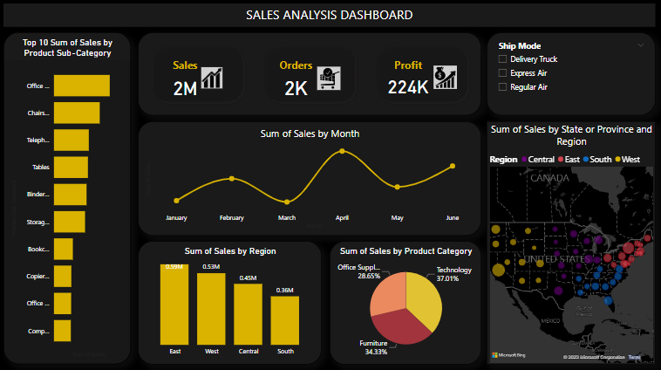



**A card visual showing Sales:** salesrepresent the total revenue generated from orders. Monitoring this metric is crucial for assessing the company's overall financial health.

**A card visuals showing Orders**: the number of orders is a fundamental indicator of customer engagement with the platform. By monitoring this metric, one can gain insight into customer activity and demand.

**A card visual showing Profit:** profit is the ultimate measure of success in business. It takes into account not only revenue but also costs. While high sales are desirable, high profits are even more critical.

﻿

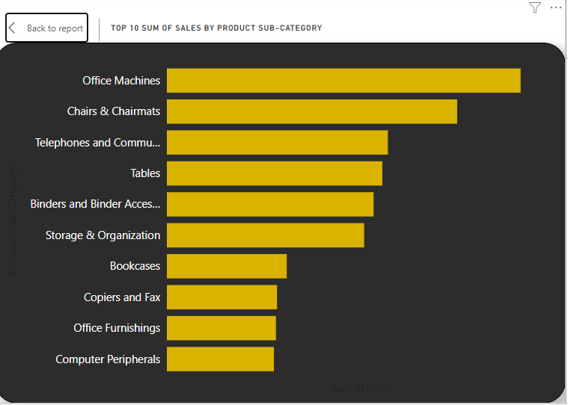

**Top 10 sum of sales by product sub-category:** Based on the analysis of the top 10 product category, I identified the most profitable products for the company. Office Machines generated the highest revenue with a total sales amount of 318,169.68. Compared to Computer Peripherals, which had the lowest sales at 96,261.30, Office Machines sales were 230.53% higher. Office Machines accounted for 18.32% of the total sales amount. The sales amount across all 10 product sub-categories ranged from 96,261.30 to 318,169.68.

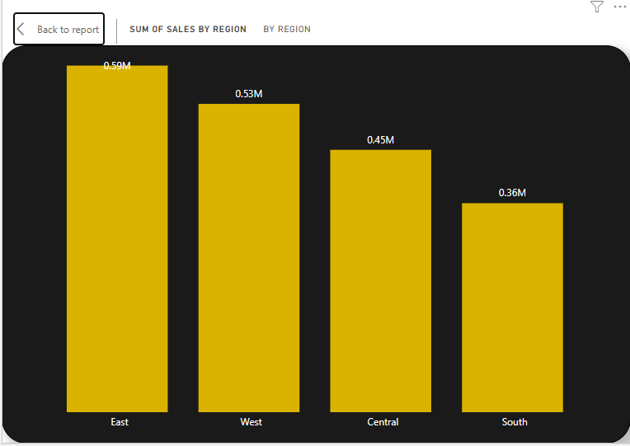

**The sum of sales by region:** Based on sales data by region, the East had the highest sum of sales at $592,171.49, which was 65.83% higher than the lowest sum of sales in the South at $357,105.12. The East was followed by the West, Central, and South in terms of sales. The East accounted for 30.77% of the total sum of the sum sales across all four regions, which ranged from $357,105.12 to $592,171.49.

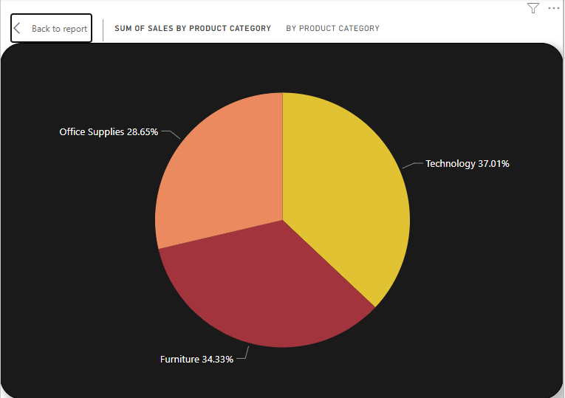

﻿**The sum of sales by product category:** Technology had the highest sales at 712,264.95, followed by Furniture at 660,704.31, and Office Supplies at 551,368.62. Technology sales accounted for 37.01% of the total sales.

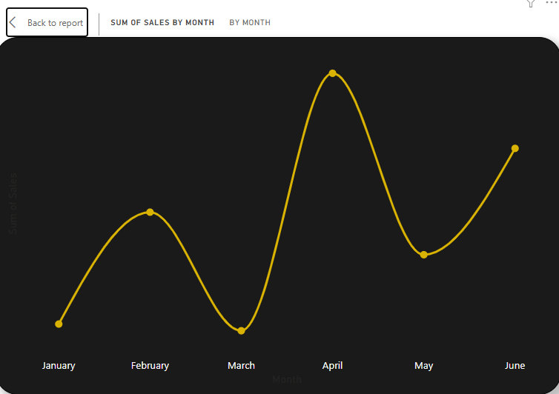

**Sum of sales by month**: In April, the Sum of Sales was the highest at 389,831.95, which was 43.48% higher than the lowest Sum of Sales in March at 271,696.67. April contributed to 20.26% of the total Sum of Sales. Throughout the six months, the Sum of Sales varied between 271,696.67 to 389,831.95.

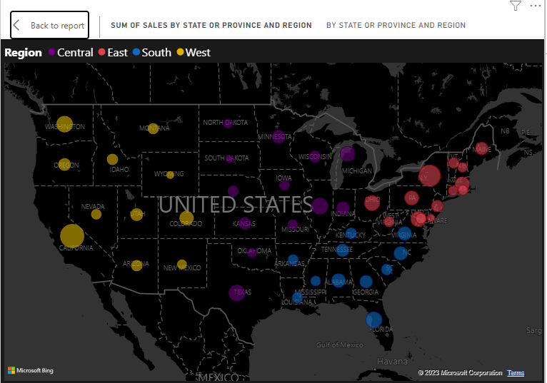

**The sum of sales by province, or state:** California had the highest sales with a sum of 288,310.61, which was 24,260.02% higher than Wyoming, the state with the lowest sales at 1,183.54. California accounted for 14.98% of the total sales. Across all 49 states or provinces, sales ranged from 1,183.54 to 288,310.61.

**PROFIT ANALYSIS**

**Overview of the Profit Analysis Dashboard**

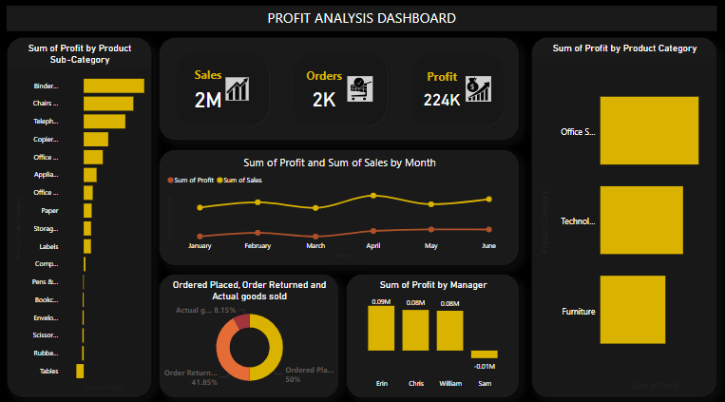

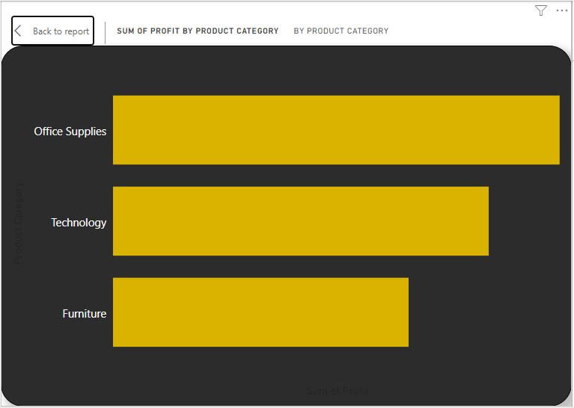

**Sum of profit by product category:** At 59,296.39, Binders and Binder Accessories had the highest Sum of Profit and was 919.00% higher than Tables, which had the lowest Sum of Profit at -7,240.07. (The profit incurred on tables is negative, which indicates a financial loss). Binders and Binder Accessories accounted for 23.81% of the Sum of Profit. ﻿Across all 17 Product Sub-Category, Sum of Profit ranged from -7,240.07 to 59,296.39.

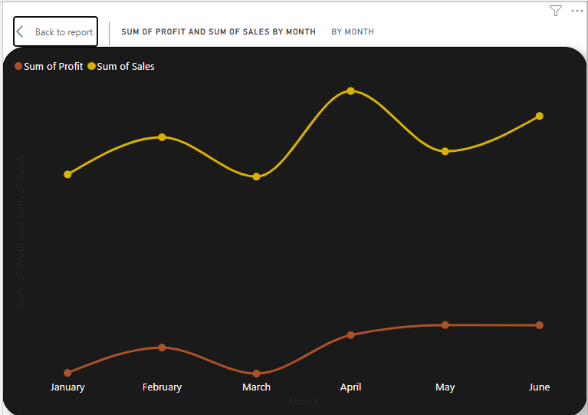

**Sum of sales and sum of profit by month sales:** At 67,002.73, May had the highest Sum of Profit and was 64,850.56% higher than March, which had the lowest Sum of Profit at 103.16.﻿ The Sum of Profit and total Sum of Sales are positively correlated with each other. ﻿May accounted for 29.90% of Sum of Profit. The sum of Sales and Sum of Profit diverged the most when the Month was April, when Sum of Sales was 336,685.54 higher than Sum of Profit.

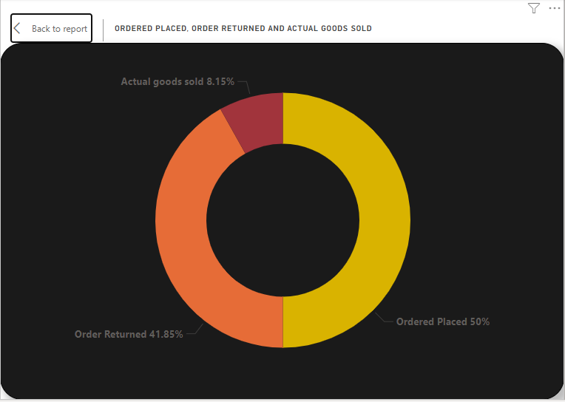

**Total Order sold:** Based on the sum of orders placed and returned, the order placement rate is 50%, while the return rate is about 41%, resulting in actual goods sold being only 8%.

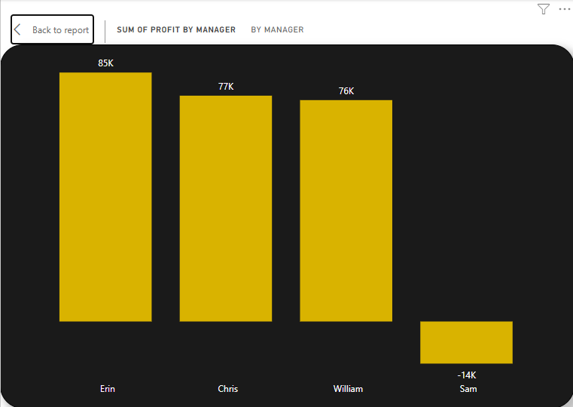

**The sum of profit by manager:** ﻿﻿Erin had the highest Sum of Profit at 85,291.40, which was 691.31% higher than Sam's lowest Sum of Profit at -14,424.05. Following Erin, Chris, William, and Sam had the next highest Sum of Profit. Erin accounted for 33.72% of the total Sum of Profit. Across all four managers, the Sum of Profit ranged from -14,424.05 to 85,291.40. This trend is similar to sales as well.

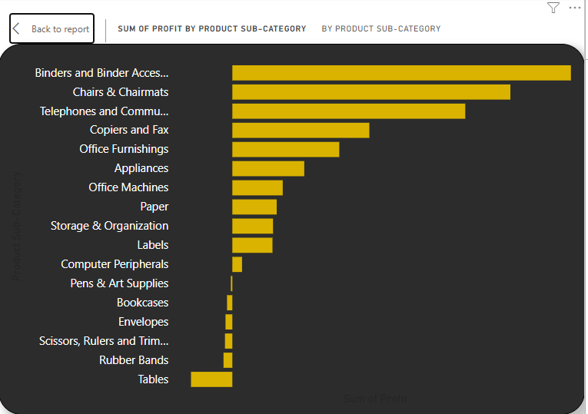

﻿﻿**Sum of profit by product category:** At 89,525.01, Office Supplies had the highest Sum of Profit and was 51.10% higher than Furniture, which had the lowest Sum of Profit at 59,249.45. Office Supplies had the highest Sum of Profit at 89,525.01, followed by Technology at 75,303.16 and Furniture at 59,249.45. ﻿Office Supplies accounted for 39.95% of Sum of Profit. Office Supplies had 89,525.01 Sum of Profit, Furniture had 59,249.45, and Technology had 75,303.16.

**RECOMMENDATIONS**

Based on the insights gathered from the sales data, I would like to recommend the following actions to the management:

1. To boost profits in product sub-categories, focus on high-performing ones like Binders. Try expanding the range, running promotions, or improving marketing. For low-performing sub-categories like Rubber Bands and Tables assess if they align with business strategy. Consider optimizing or phasing out underperforming categories to allocate resources efficiently. Evaluate pricing, costs, and demand to optimize profitability

2. To maximize profits in terms of location, it's important to focus on the East region as it has the highest sales. To maintain the momentum and continue increasing sales in this region, consider allocating additional resources or expanding product offerings. On the other hand, the South region is experiencing lower sales. Investigate the reasons behind this underperformance and tailor marketing strategies or promotions to target these regions, to boost sales and profitability.

3. Using the monthly sales data, noting monthly variations and product seasonality to plan marketing campaigns strategically based on product seasonality and maintain/improve profit margins during high-sales months to increase revenue. May had the highest profit margin.

4. Encourage cross-selling and upselling: Identify opportunities to cross-sell or upsell related products to customers. For example, when customers purchase Office Machines, suggest additional products like Office Supplies or Furniture to increase the overall sales amount.

5. Target California: California had the highest sales, accounting for 14.98% of the total sales. Allocate more resources and marketing efforts to penetrate the California market further. Investigate the factors contributing to the success and explore opportunities to replicate this success in other states/provinces.

6. Recognize and reward high-performing managers like Erin, who consistently achieve top sales and profits. Analyze her strategies to identify best practices for the team. Provide support or training to managers with lower sales and profits to improve their performance.

7. Address Order Returns: Reducing return rates is key to a successful business. High return rates indicate issues with product quality, order accuracy, and customer service. Improving these areas can boost profitability and customer loyalty. Investigate reasons behind returns, enhance product information, ensure accurate orders, and improve customer service. Prioritize customer satisfaction.

It's important to consider that a business may not be as profitable as it appears based on high sales alone. While high sales indicate market demand and revenue, it's the profit margin that truly reflects the financial health and sustainability of the company. When a business has significantly higher sales than profits, it indicates a low-profit margin. This is the current situation for this business and can pose challenges for investing in growth, repaying debts, and paying dividends to shareholders. Over time, a company can't thrive on high sales without generating enough profit, putting its sustainability at risk. This situation can be looked into by reducing the level of return orders as recommended above.

During the sales analysis, it became clear that the highest sales figures were achieved by different products and product categories than the ones that yielded the greatest profits. This is due in part to the level of returns.

Implementing these recommendations can help the company leverage its top-selling products, target profitable regions, and optimize sales and profitability.